Private Inbound

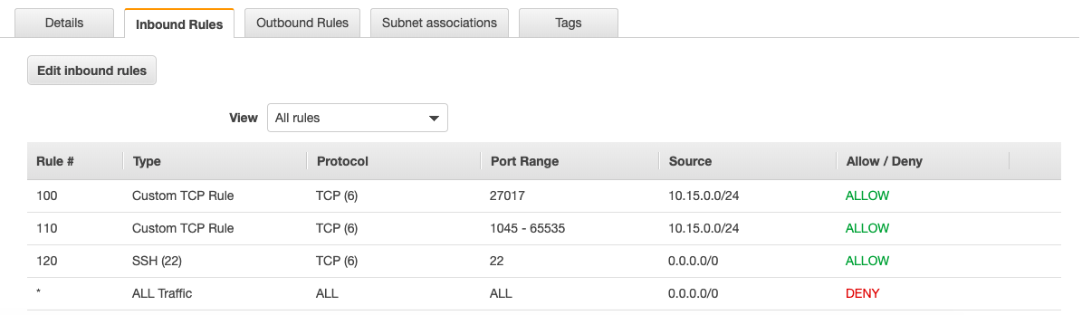

Private Outbound

